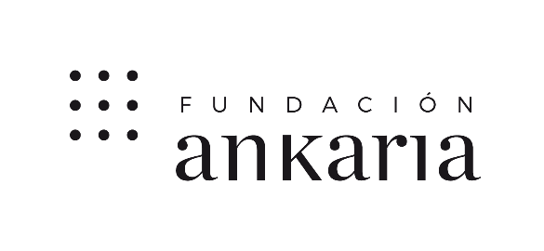

VII ANKARIA ARTIST BOOK AWARD

The Ankaria Foundation announces the VII Ankaria Artist Book Award, an initiative launched in 2014 associated with the exhibition "The Painted Word", and which aims to promote the production of artist books among the creative community

BASES
1.- Participants.-
Allowed any artist over 18 years old.
2.- Works. -
2.1.- Each artist may present a single work, of free theme and size, original and unpublished, that has not win another prize or contest.
2.2.- The work may be presented in any format within the artist's book type, but may not contain perishable items or materials that may be considered dangerous.
3.- Details and documentation.-
3.1.- The presentation of the work of each artist will be sent by email to the following address: info@fundacionankaria.org, and must be specified in the subject:
"VII Ankaria Artist Book Award - Title of the work - Name and Surname of the author".
3.2.- The following files must be attached to the email:
- A maximum of 5 images of the presented work, identified with the information about it and the author.
- Registration form fully completed.
- Technical data of the work.
- Statement

4.- Hand delivery or shipping of the works and the corresponding documentation. -

4.1.- The period for the presentation of works will close on July 30, 2020, at 8:00 p.m.

4.2.- The Jury may request the physical delivery of the work, in case it cannot be properly assessed by the images submitted.

4.3.- In that case:

- The work may be delivered by hand or sent properly packed to: Fundación Ankaria; Peña del Yelmo street, nº 4; 28023, Madrid, Spain from 10:00 to 19:00, from Monday to Friday.
- The work will be presented ready to be exhibited.
- If necessary, a description of the assembly and specifications of installation will be included, providing the necessary elements for its correct exposure.
- The costs of packaging and transport are borne by the participants.

5.-Selection of the work and awards. -

5.1.- The Jury will be formed by the members of the Board of Trustees of the Ankaria Foundation.

5.2.- The Jury will meet once the deadline for submission is finished to select those deserving of the Prize, taking into account the criteria of originality, aesthetic expression, composition, creativity and technical procedures used.

5.3.- The decision of the Jury will be unappealable and will be made public as of September 15, 2020, on the Foundation's website: www.fundacionankaria.org.

5.4.- The VII Ankaria Artist Book Award will be endowed with the following amounts:

- € 3,000 for the first selected work, winner of the VII Ankaria Artist Book Award.
- € 1,500 for the second selected work, finalist of the Prize.
- € 1,000 for the first selected work among those submitted to the Award by artists under 28 who have not obtained any of the two previously related prizes, which will be the winner of the Javier Rosón Pérez Special Award for Artist Books by young creators.

5.5.- The amounts corresponding to the Prize are subject to the current tax legislation.

5.6.- In addition to the monetary award described:

- The winning works will be included in the itinerating exhibition "The Painted Word".
- The winner of the First Prize of the VII Ankaria Artist Book Award, will appear in the G&E magazine with a review of his/ her career and his/ her work.

5.7.- The awarded works will become part of the Artistic Heritage of the Ankaria Foundation, who in accordance with the provisions of the Law on Intellectual Property, its authors cede, as an exclusive feature and automatically, all the property rights of exploitation of such works.

6.-Exhibition.-

6.1.- The awarded works will be included, among others, in the itinerant exhibition " The Painted Word "

6.2.- The organization, although it will try to take into account the indications of each artist regarding his work, will ultimately decide how the selected works are shown.

6.3.- The rights of reproduction, distribution and public communication of the awarded works that are included in the already mentioned exhibition will belong to the Ankaria Foundation by virtue of the assignment of all the property rights of exploitation of such works that has been described above.

7.-Return of the works.-

7.1.- Works not selected for the Prize whose physical delivery has been requested by the Jury, may be withdrawn by hand at Fundación Ankaria; Peña del Yelmo street, nº 4; 28023 Madrid, Spain from 10:00 to 19:00, from Monday to Friday. If any of them has not been withdrawn, it will be understood that the author has voluntarily renounced the ownership of the same in favour of the Foundation, which reserves the right to destroy them or include them in their collection.

7.3.- The works whose authors request via email that are returned by courier will be paid by cash on delivery.

8.-Other specifications

8.1.- The organization will put the maximum effort in the care of the received works, but will not be responsible for the damages that could be derived from the transportation.

8.2.- Participation in this call implies the total acceptance of these bases.

8.3.- The bases can be downloaded at www.fundacionankaria.org

